Cell cycle
The cell cycle is a highly regulated sequence of events that governs the growth, replication, and division of eukaryotic cells, ensuring accurate duplication and distribution of genetic material. It is essential for development, tissue repair, and maintaining homeostasis, but dysregulation can lead to diseases like cancer.

Phases of the Cell Cycle
The cell cycle is divided into two main phases: interphase (preparatory, ~90% of cycle) and M phase (mitotic division).

Interphase:
  - G1 phase (Gap 1): Cell growth, synthesis of proteins and organelles; checkpoint assesses DNA integrity and nutrient availability.
  - S phase (Synthesis): DNA replication occurs, duplicating chromosomes (from 2n to 4n); histones synthesized.
  - G2 phase (Gap 2): Further growth, preparation for mitosis; checkpoint verifies DNA replication accuracy.
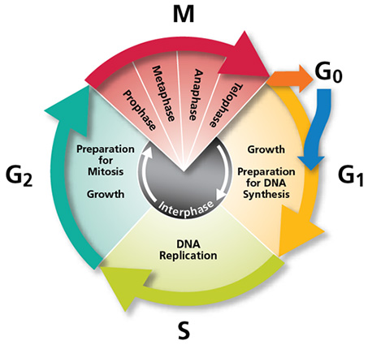

M Phase (Mitosis and Cytokinesis):
  - Prophase: Chromatin condenses into chromosomes; nuclear envelope breaks down; spindle fibers form.
  - Metaphase: Chromosomes align at equatorial plate; spindle attaches to kinetochores.
  - Anaphase: Sister chromatids separate and move to poles via shortening spindles.
  - Telophase: Chromosomes decondense; nuclear envelope reforms; followed by cytokinesis (cleavage furrow in animals, cell plate in plants), dividing cytoplasm into two daughter cells.
[CLINICAL]Cells may enter G0 phase (quiescent) for non-dividing states (e.g., neurons).

Regulation
- Cyclins and CDKs: Progress driven by cyclin-dependent kinases (CDKs) activated by cyclins (e.g., Cyclin D in G1, Cyclin A/B in S/G2/M). Levels fluctuate cyclically.
- Checkpoints: G1/S (DNA damage), G2/M (replication errors), spindle assembly (metaphase). Tumor suppressors like p53 and Rb enforce these.
- External signals: Growth factors (e.g., PDGF) initiate cycle via signaling pathways.
[WARNING]Clinical Relevance: Aberrant cycles cause uncontrolled proliferation in cancer; therapies target CDKs (e.g., palbociclib).

